DRAWING with Lionel Sanchez

Study line observation and actual drawing while considering the principles and elements of design.

Thursday– 9:30 to Noon
Fee: 5 Week Session $70 ($95 non-member)

Oct. 8 – Nov. 5

DRAWING – with Ernesto Blanco
Live model portrait. Focuses on the structure of the human head and its proportions.

Saturday 1:00 – 3:30
Fee: 5 Week Session $70 ($95 non-member)

Oct. 10– Nov. 7

WIRE ART – with Melinda Paproski

Saturdays 1:00 - 3:30
Fee: 5 Week Session $70 ($95 non-member)

Students will cut our metal shapes to form objects for the garden or art for the house. Examples would be flowers, insects such as a butterfly, dragon fly or even a bird. Students will paint the objects as well.

Nov. 14 – Dec. 18

Note: Dates & times are subject to change
Please verify by checking our website store or calling
the Center for any changes that might have taken place.

No Class week of Thanksgiving
Center is closed From Dec. 20 – Jan. 5

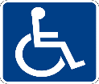
Our facility is wheelchair accessible, persons
who wish to request disability
related accommodations can contact PFAC’s Accessibility Coordinator at: 727-845-7322

POTTERY with Christa Stanelun

Acquire basic knowledge of the art of pottery. Coil, pinch, slab, wheel, glazing.

(Materials must be purchased in class - Clay & Glazes at cost of $20 per 20 lb bag)

All levels: Beginning to advanced. Age 16 to adult.
Fee: 5 week session
$75member ($95 non-member) includes firing fee
Tuesday Morning Classes - 9:30 am – Noon
Tuesday Evening Classes – 5:30 – 8:00pm
Class size limited to 8 students.

Sept.1 – Sept. 29
Oct. 6 – Nov. 3
Nov. 10– Dec. 15

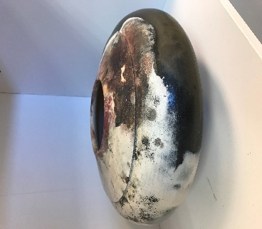

POTTERY WHEEL with Denise Philbrook

Learn the basics of throwing on the wheel: including preparation of the clay, centering, shaping and trimming.
(Materials must be purchased in class - Clay & Glazes)

Thursday Evening 5:30 – 8:00
Friday – 9:30 - Noon
Fees: 5 Week Session: $75 ($95 non-member)
Includes firing fee
All Levels: Ages 16 to Adult

Thursday  Sept. 3 – Oct. 1  Oct. 8 – Nov. 5  Nov. 12 – Dec. 17 | Friday  Sept. 4 – Oct. 2  Oct. 9– Nov. 6  Nov. 12 – Dec. 18
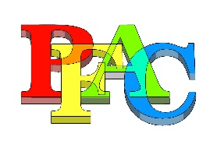

PASCO FINE ARTS COUNCIL
CLASS SCHEDULE

September 2020 – December 2020

Note: All Classes will be limited to
8 students due to the to ensure appropriate class size, students
MUST
sign up and pay prior to the first day
of class (no exceptions!)

INTERMEDIATE WATERCOLOR
with Jo Baughman

Fees: 5 Week Session
$70members ($95 non-member)

Wednesdays 9:30 - Noon
Emphasis on various techniques and subject matter.
Begin to recognize and utilize the Principles and
Elements of Design and Composition – essential in the
development of a fine artist.

Sept. 2 – Sept. 30
Oct. 7 – Nov4
Nov. 11 – Dec. 16

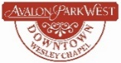
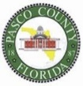
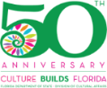

WATERMEDIA - with Suzanne Natzke

Tuesdays 1:00 – 3:30
Fees: 5 Week Session: $70 ($95 non-member)
(See website for materials list or ask at the reception desk)

Level: Experienced Beginners to Advanced

Sept 1 – Sept 29.

The Art of Lost Lines – Learn the function of lost lines, how to plan them and where to put them.

Oct. 6 – Nov. 3

Get Moving in Watercolor– Explore techniques for portraying motion in a variety of subjects including
windy days, bodies and vehicles on the move, ocean
spray, and other natural elements.

Nov. 10– Dec. 15

Animals & Pets in Watercolor – Take a simplified approach to painting the many textures and patterns
found in the animal kingdom.
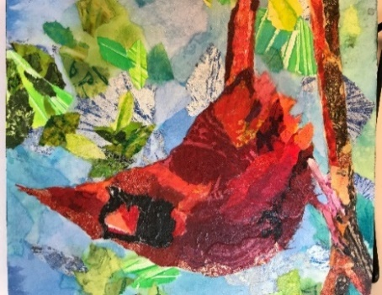

6/16/20

ACRYLIC & OIL CLASSES with Lisa Owens

5 Week Session: $70 ($95 non-member)

Tuesday: 9:30 – 12:00pm
Level: Beginners to Advanced
For the experienced beginner to advanced artist looking to improve their painting technique and skill. Experienced beginners through advanced may work on their own pieces or participate in class studies. Work in oil or acrylics.

Sept.1 – Sept. 29
Oct. 6 – Nov. 3
Nov. 10– Dec. 15

Wednesday1:00 – 3:30 pm
Level: Beginners to Advanced
For the experienced beginner to advanced artist looking to improve their painting technique and skill. Experienced beginners through advanced may work on their own
pieces or participate in class studies. Work in oil
or acrylics

Sept. 2 – Sept. 30
Oct. 7 – Nov. 4
Nov. 11– Dec. 16

CRITIQUE with Suzanne Natzke
Last Friday of each month (except on holidays) ($5 cash per session) If you would like to receive an invitation, please email
pacart3@gmail.com to be placed on the list.

Pasco Fine Arts Council, Inc.
4145 Fairford Drive
New Port Richey, FL 34652
727-845-7322
www.pascoarts.org

BEGINNING WATERCOLOR BASICS
with Jo Baughman

Fees: 5 Week Session
$70 ($95 non-member)

Thursdays 9:30-Noon
For the beginning student who has never painted before or who has not painted for a long time.

Sept. 3 – Oct. 1
Nov. 12 – Dec. 17

OPEN PAINTING – ALL MEDIUMS

Fees: 5 Week Session
$$50 ($75 non-member)

Thursdays 1:00 – 3:30
For the seasoned artist in all medium. Bring your own subject matter. Instructor will provide assistance and suggestions in techniques, composition, color mixing, and critique your own work.

Sept. 3– Oct. 1
Oct. 8 – Nov. 5
Nov. 12 – Dec. 17

TEEN ART CLASS (Ages 12 +)
with Jo Baughman
Fee: 5 Week Sessions
$70 ($95 non- Member)
All levels

Saturday 9:30 – 12:00
Serious Art students only (all levels) covers drawing, painting, and other medium and forms of art.
The student will learn to establish a “portfolio” of artwork.

Sept.5 – Oct. 3
Oct. 10 – Nov. 7
Nov. 14 – Dec. 19

